Clarence Gardens Breakfast Menu

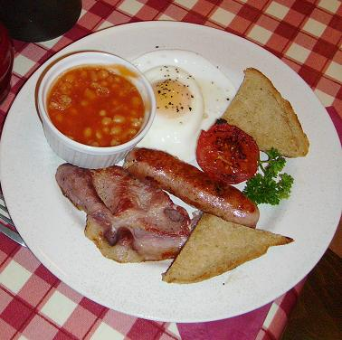
Please place your order at the till
Served between 8.00 & 10.00 am

Continental Breakfast £4.95

Help yourself to a wide selection of continental items including:- fruit juice, cereals, melon, grapefruit, yoghurts including natural, fresh fruit, prunes, apricots, strawberries, mandarins, cold meats, cheeses, ‘Yorkshire Honey’, brown and white toast, muffins, local preserves, tea(including fruit teas and Earl Grey) and coffee.

All the options given below include
The Continental Breakfast

The Big Breakfast £7.95
Bacon, locally made sausage, tomato, beans, mushrooms, fried bread, sauté potatoes
locally made black pudding & fried egg.

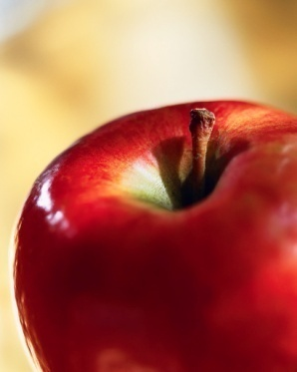
The Regular Breakfast £6.95 Bacon, locally made sausage, beans, fried bread, tomatoes & fried egg.
The Farmhouse Breakfast £6.95
A choice of fried, poached or scrambled egg served on toast.

The Woodland Breakfast £6.95
Mushrooms bound in a creamy sauce served on toast.

The Seaside Breakfasts £6.95
‘Whitby’ Smoked haddock served with poached eggs.

‘Whitby’ Kippers served with poached eggs, brown bread & butter.
WARNING: Please be aware that bones may be present within the haddock & kippers!

Croissants £5.95
Two warm croissants served with butter and preserves.

Children’s continental counter £3.95
Children’s Cooked Breakfast £4.95

Choose 3 from the following: - bacon, sausage, beans or egg.

Children’s continental - under 3 £2.95

